Week of August 5, 2008 Anne Schellman, Horticulture Associate
aschellman@ucdavis.edu

CARROTS

As both a horticulturist and a gardener, I’m constantly on the lookout for new and exciting vegetable varieties. An article in Small Farm News (Volume 2, 2007) regarding carrots by Aziz Baameur, recently caught my attention.
The University of California Cooperative Extension is researching the performance of various carrot types to determine their yield in a small farm setting. The carrots in the study include shades of white, red, green, yellow, purple and almost black. The reason carrots in grocery stores today are orange dates back to the 15th century. During this time, the Netherlands was in a struggle for independence. The House of Orange developed the orange carrot as an emblem of its struggle. The color stuck and remains the most popular carrot color in the Western part of the world.

I visited several nurseries and garden centers looking for unusual seed colors. However, the only one I could locate is a type called “Rainbow.” This packet has a blend of orange, white and yellow carrot varieties. However, nursery people assured me that colorful carrot seeds can be ordered upon request.
For gardeners who wish to find carrot seed online, try Kitchen Garden Seeds, Territorial Seed Company or Kitazawa Seed Company. Each of these companies features a selection of various colored carrots. However, at this time I have been unable to locate sources of green or black carrot variety seeds.
In my garden I will be growing “Purple Dragon,” “Atomic Red,” “Yellowstone,” “Snow White,” “Solar Yellow,” “Lunar White,” “Purple Haze,” and “Kyoto Red.”
I’m using Mel Bartholomew’s "Square Foot Gardening" as a guide for planting carrots. Although carrot seeds are tiny, the author does not advise following the norm of sprinkling them along a row. This is because once seeds sprout; many gardeners are overwhelmed with the chore of thinning. The author divides gardening space into 4’ squares, lining them with 1’ boards for easy walking/planting access. The divisions prevent gardeners from overplanting, which often happens when planting seed. So for carrots, in a 4’ square, use a finger or string to divide it into 16, 1’ squares, then, each of these squares into 16, 3.” Add a single seed to each small square and covers it lightly. (See diagram)

Continued . . .

August 5, 2008
News Release
Page 2

Carrot seeds germinate best when soil has good drainage and is free of dirt clods. Add compost to the soil and mix to a depth of at least 12 inches. Keep soil moist while seeds sprout, as this can take up to 2 weeks. Carrot seeds can be easily washed away, so water lightly. During this warm month of August, do not let the soil crack or crust over.

We will be installing a school garden demonstration plot here at the Cooperative Extension behind our building. I’ll be blogging about its progress as well as the carrot patch at http://cestanislaus.ucdavis.edu/Gardening/Garden_Blog.htm Please feel free to make comments or detail your experiences with growing carrots or gardening in general. Or send me an e-mail at aschellman@ucdavis.edu

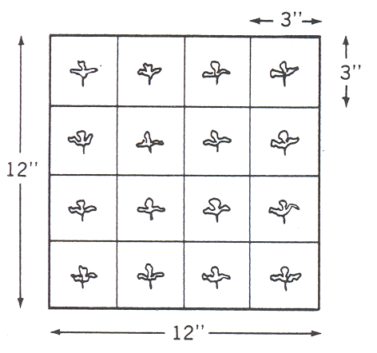

Taken from Square Foot Gardening

If you decide to use the picture attached, the photo credit belongs to Aziz Baameur,he raised the carrots and decided to cook up a colorful plate.

# # # # #

AS/mh

